Portable Low Cost Ventilator

Prof. M. S. Pawar1, Aniket Ghage2, Yug Samyak3, Anurag Meshram4, Ruchika Kokate5, Chirag Patel6

[mahesh2323@gmail.com](mailto:mahesh2323@gmail.com)1 [aniketghage@gmail.com](mailto:aniketghage@gmail.com)2, [yug.bhajikhaye@gmail.com](mailto:yug.bhajikhaye@gmail.com)3, [anuragmesh@gmail.com](mailto:anuragmesh@gmail.com)4

[ruchikakokate57@gmail.com](mailto:ruchikakokate57@gmail.com)5, [chirag1064@gmail.com](mailto:chirag1064@gmail.com)6

Department of Electronics Engineering

Yashwantrao Chavan College of Engineering, Nagpur, India

***Abstract***

*This paper is written to focus on the development of a non-invasive, user-adjustable mechanical ventilation for patients suffering from respiratory problems. The patients are fed with controlled breaths given by a feedback loop system i.e. a pressure transducer and a flow rate transducer. All the user input is fed by the doctor, and are displayed on the monitor. The sensors will feed back the signals to the microcontroller, which will perform operations like converting the signal into pulse width modulation signal to check any error and synchronize the breathing cycle. The wide range of settings enable us to digitally control the ventilator according to the patient's needs. DC high pressure blower air pump, with electronic speed controller, is PID tuned and is replaceable with similar pumps after tuning. The ventilator uses replaceable sensors for dynamic modification of transfer functions. The result is the design and making of a portable low cost ventilator that can be used in ambulances, small hospitals and during disaster management to provide volume and pressure-controlled air for mechanical ventilation.*

**I. *Introduction***

Ventilators irreplaceable lifesaving equipment, it is a closed loop system that aids in artificial breathing by regu- lating the quality and quantity of air being delivered to the human body at any given time. Mechanical Ventilators are required in seven major departments like medicine, pediatrics, pediatric surgery, surgery, orthopedics, chest medicine and TB, ENT and gynecology. A major impediment to their availability in small hospitals and clinics, especially of 3rd world countries, is their cost and the need for specially trained staff to operate and maintain such complex devices.

***A. Negative Pressure Ventilation***

In Negative-pressure ventilation (NPV) the air pressure supplied to the thorax during inspiration is subatmospheric pressure which causes thoracic expansion and a decrease in pleural and alveolar pressures, which results in pressure gradient causing the air to move into the alveoli from the airway opening. As soon as the pressure surrounding the thorax increases and becomes atmospheric or greater, elastic recoil of the respiratory system causes expiration to occur passively. The change in inspiratory

pleural and alveolar pressures, which changes the NPV, in, replicate those during spontaneous breathing. On the contrary, positive-pressure ventilation (PPV) causes an increase in intrathoracic pressures during inspiration. Due to upper airway obstruction and hypoxemia during sleep, Negative-Pressure Ventilation

is used in only a few situations. As it does not require a tracheostomy it is a suitable and attractive option for patients with neuromuscular disorders, those with residual muscular function.

***B. Positive Pressure Ventilation***

In Positive-pressure ventilation, the airway pressure applied at the patient's airway through an endotracheal or tracheostomy tube is larger than the pressure at the airway of the lungs, which allows the air to flow into the lungs until the breath is terminated. As soon as the breath is terminated the airway pressure drops to zero and elastic recoil of the lungs pushes out the air within it making a passive exhalation.

Positive pressure ventilation can be delivered in two forms: Invasive Positive Pressure Ventilation (IPPV) which involves the delivery of positive pressure to the lungs through an endotracheal tube or tracheostomy and Non-Invasive Positive Pressure Ventilation (NIPPV), which is delivered through a special face mask with a tight seal (air travels through anatomical airways). A breath during positive pressure ventilation can be characterized by changes in pressure, volume, and flow during inspiration and expiration. Mathematical expression which expresses these principles is :

*Paw = P1 +( Ee + Vt) + ( flow + R)*

Where P1=initial alveolar pressure, Paw = airway pressure, Vt = tidal volume, R = resistance to flow, Ee = inherent elastance of the pulmonary system.

**II. Design Methodology**

Arduino Nano V3.0 microcontroller is the brain of this system, it interprets, sends, controls data which has been given via front panel settings knobs and all the parameters that are given to the system are displayed on LCD which acts like a user interface. Microcontroller processes this data and caliberates it with the real time values that are fed to it by two analog pressure transducers, placed after the custom made BLDC blower. This forms a closed loop system where data is simultaneously interpreted and controlled.

***A.*** *Input Methods And Parameters*

High end Invasive Ventilators work on different parameters like: Respiratory Rate, Inhale to Exhale Ratio (I:E Ratio), Tidal Volume (Tv), Oxygen Concentration (O2), Flow Rate Sensitivity, Trigger, PEEP, but, since, non invasive ventilators are not made for emergency use rather just to support the breathing of stable patient, these all parameters are not that needed and uses I:E Ratio, Respiratory Rate, Trigger and Sensitivity, modes- BiPAP and CPAP.

This ventilator uses above parameters, which are fed by the doctor using graphical user interface and knobs placed on the front panel as shown in Figure II.1. These parameters are then fetched to Arduino Nano which will process it using an algorithm.

***B.*** *User Interface*

Once the doctor gives required parameters through the input methods to the ventilator, the microcontroller will make it user readable and fetch it to an LCD Display and the doctor can see the settings of the machine. This user interface makes it easy for the doctor to check whether the input parameters are the same which he had given with the help of input methods and it is reliable for anyone to monitor the patient. The user interface is shown in Fig. II.1

***C***. *Loop And Feedback*

The parameters given by the doctor are then processed by Arduino Nano with the help of an

algorithm, which converts user readable data to machine readable data and controls the motor

driver which changes the speed of the pressure blower to obtain the required set of outputs that

matches the inputs given by the doctor. The pressure transducer converts physical air pressure,

which falls on to it, to analog signals that are in proportion to the applied pressure and sends it to the microcontroller.

Before ground isolation is done, analog signals by the sensor to the microcontroller are converted to variable duty cycle Pulse Width Modulation signals through inbuilt programming. This is achieved by generating a saw-tooth signal of required frequency. Analog output from sensors act as reference signals which when fed to a comparator along with saw-tooth signal generates PWM signals. These signals vary in duty corresponding to varying analog voltage levels. After performing operations it will adjust the signals that it sends the motor driver to control the blower for the desired output.

***D.*** *Pressure controlled Breathing Cycle*

The ventilator has two modes- BiPAP and CPAP, and it will perform accordingly as the mode set by the doctor. In BiPAP (Bi-Level Positive Airway Pressure) a high level of pressure is maintained during the inspiratory cycle and a low level during expiratory cycle, such that it matches the patient's needs. In CPAP, a constant pressure is maintained at any point of time, such that the lungs are kept open throughout the breathing cycle. The pressure never drops below PEEP (Positive End Expiratory Pressure), as set by the doctor ,such that no vacuum builds in lungs set by the doctor.

The mandatory breaths are pressure controlled breaths which cycles at preset breathing rate known as Breaths Per Minute, and it is adjustable according to the patients need.

***E.*** *Pressure Control*

Speed controller for BLDC air pump is an Electronic Speed Controller which is controlled by Arduino Nano V3.0. This ESC has 2 MOSFETS which regulates the power to BLDC motor upon receiving signals from microcontroller.

This ESC LC low pass filter is used to remove ripple and unwanted noise. Typical inductor choice for this purpose is a ferrite drum and iron powder inductor. During ON state of the MOSFET, the inductor stores energy and releases it to the load. During OFF state, energy is freewheeled through the 2nd MOSFET.

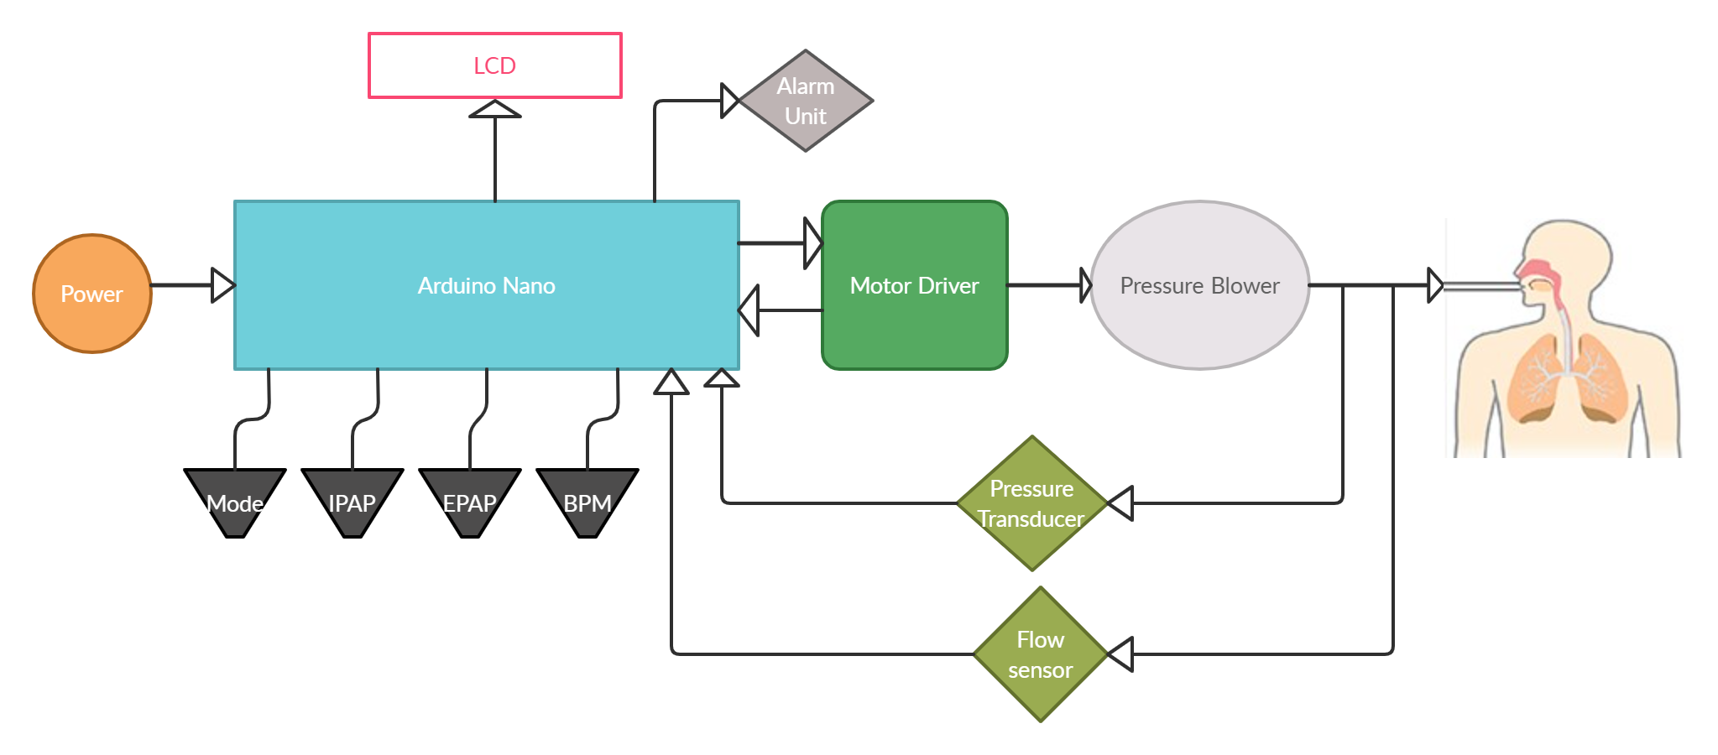

Fig. II.1

**III. Experiments And Results**

***A*.** *Blower Performance*

The blower is operated at 12V, 15V and 24V and we get the respective performance characterized by the flow(l/min) vs pressure graph(cmH2O). At 12V the output pressure of the blower is 17cmH2O,

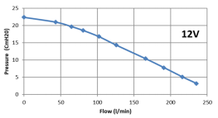

Fig. III.A.1

at 15V for zero flow it is 30cmH2O but at the flow rate of 100 l/min the pressure drops just to 25cmH2O.

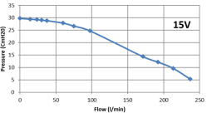

Fig. III.A.2

At 24V the output pressure is 66cmH2O.

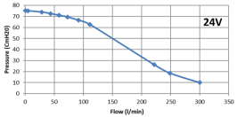

Fig. III.A.3

In Conclusion we can say that operation at 24V will give us desired output pressure required

***B****. Results*

To test, whether the ventilator performs mandatory inspirations or not, normal breathing rate of 12 bpm was set from the front panel and patient was asked to breathe with his glottis closed and start an end inspiratory cycle, the ventilator performed it’s mandatory cycle from seconds 12 to 30, with probable fluctuations due to intended leak during the cycle.

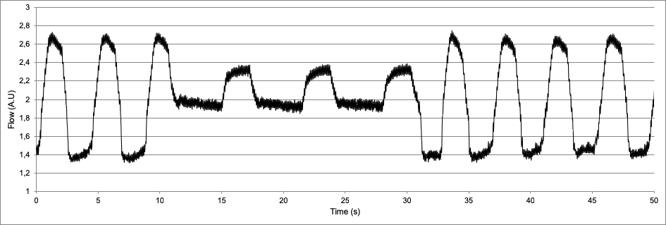

Fig.III.B.1 Flow rate reading

**Conclusion**

The user-friendly model has been developed as a proof-of-concept and further development is lined up for actual use after all the tests are done and matches the required parameters in near future. Modifications are required for its preciseness and repeatability so that it meets a medical ventilator criteria. The weight of the ventilator is 1200 grams and dimensions of 9 x 9 x 3 inch, which makes it portable. Currently it is able to assist control and operate in two modes (BiPAP and CPAP) with Pinsp, Pexp and BPM as parameters. Besides that It uses components which are easily accessible with very few moving parts, system optimization is under consideration for optimum functionality. Tidal volume is found to be sufficient while conducting tests for patients with 12-15 BPM. Ways to minimize errors from pressure sensors and increase the efficiency of the motor will be explored. Overall design is under optimization for user compatibility.

**IV. References**

1. Available: https://e-vent.mit.edu.
2. ERS Journals: https://doi.org/10.1183/13993003.00846-2020
3. Deshmukh, A.D.; Shinde, U.B. A low cost environment monitoring system using raspberry Pi and arduino with Zigbee. In Proceedings of the 2016 International Conference on Inventive Computation Technologies (ICICT), Coimbatore, India, 26–27 August 2016; Volume 3, pp. 1–6.
4. Bhargava, A.; Kumar, A. Arduino controlled robotic arm. In Proceedings of the 2017 International conference of Electronics, Communication and Aerospace Technology (ICECA), Coimbatore, India, 20–22 April 2017; Volume 2, pp. 376–380.
5. El Majid, B.; El Hammoumi, A.; Motahhir, S.; Lebbadi, A.; El Ghzizal, A. Preliminary design of an innovative, simple, and easy-to-build portable ventilator for COVID-19 patients. Euro Mediterr. J. Environ. Integr. 2020, 23, 1–4. [CrossRef]
6. Vasan, A.; Weekes, R.; Connacher, W.; Sieker, J.; Stambaugh, M.; Suresh, P.; Petersen, J. MADVent: A low-cost ventilator for patients with COVID-19. Med. Devices Sens. 2020, 3, e10106. [CrossRef]
7. [online] Available Springer: Preliminary design of an innovative, simple, and easy-to-build portable ventilator for COVID-19 patients | SpringerLink
8. [Online] Available Student manual Ventilators: https://adph.org/ems/assets/StudentManual_Ventilators.pdf
9. Laura C. Myers, Stephen M. Parodi, Gabriel J. Escobar, and Vincent X. Liu. Characteristics of Hospitalized Adults With COVID-19 in an Integrated Health Care System in California. JAMA, 323(21):2195–2198, 06 2020.
10. Rishi K. Wadhera, Priya Wadhera, Prakriti Gaba, Jose F. Figueroa, Karen E. Joynt Maddox, Robert W. Yeh, and Changyu Shen. Variation in COVID-19 Hospitalizations and Deaths Across New York City Boroughs. JAMA, 323(21):2192–2195, 06 2020.